University of Nebraska Kearney NCC Mini Grant Final Report 2015

Project Objectives
The specific objectives set based on UNK’s strategic plan are:
- Reducing students’ misperception of their peers’ alcohol use
- Reduce drinking and driving.

Project Activities
1. Conceptualize and develop social norms messages.
2. Hire Student Workers and assign prevention projects.
3. Further develop “The Safe Ride” Program through collaborations and advertising.

- Social Norms Messages
As stated in our proposal, a media campaign was developed in order to address students’ misperceptions about their peers’ alcohol use, to promote the SAFE Ride Program, and to increase interaction with our social media sites. The Fact or Yak project was a two day social and digital media blitz which provided alcohol education about how alcohol works, promoted the safe ride, and redirected students to our social media pages.

  - Fact or Yak/Safe Ride T-Shirts – 50 custom T-shirts were funded by NCC Mini grant to promote our efforts among UNK students.

Students who followed, retweeted and favorited our “Fact or Yak” tweets became eligible to receive one of the t-shirts.

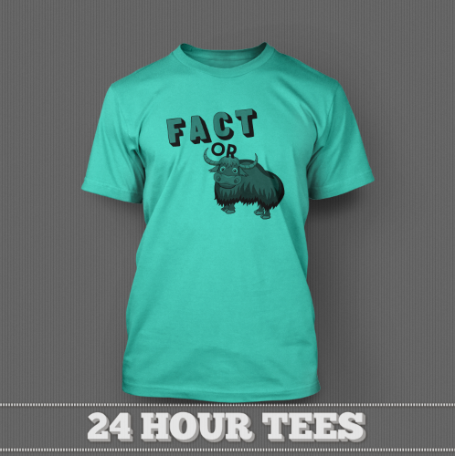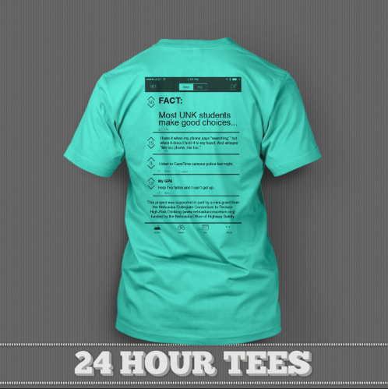

We had many students engage with us on Twitter, Facebook and Yik Yak and we displayed digital images on these social media platforms as well as displayed our Fact or Yak Poster on every computer screen on campus.

Digital Messages:

Computer Displays around Campus
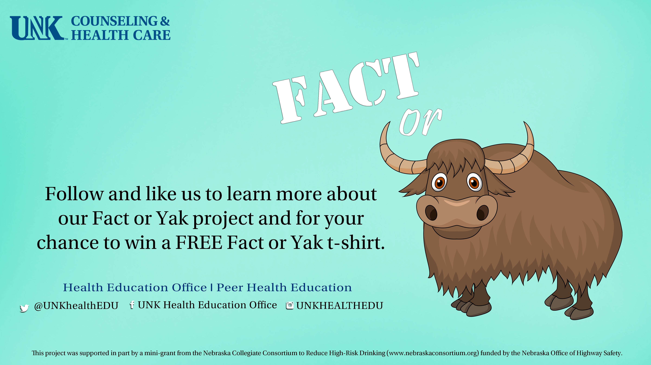

Twitter Cover Photo


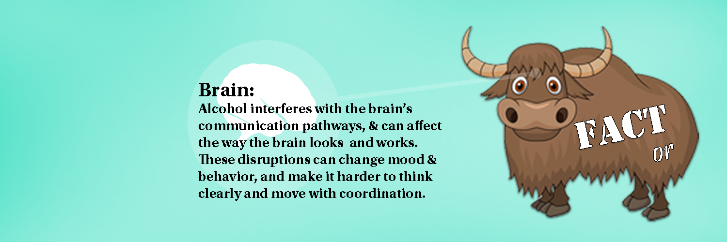

Facebook Cover and Profile Photos
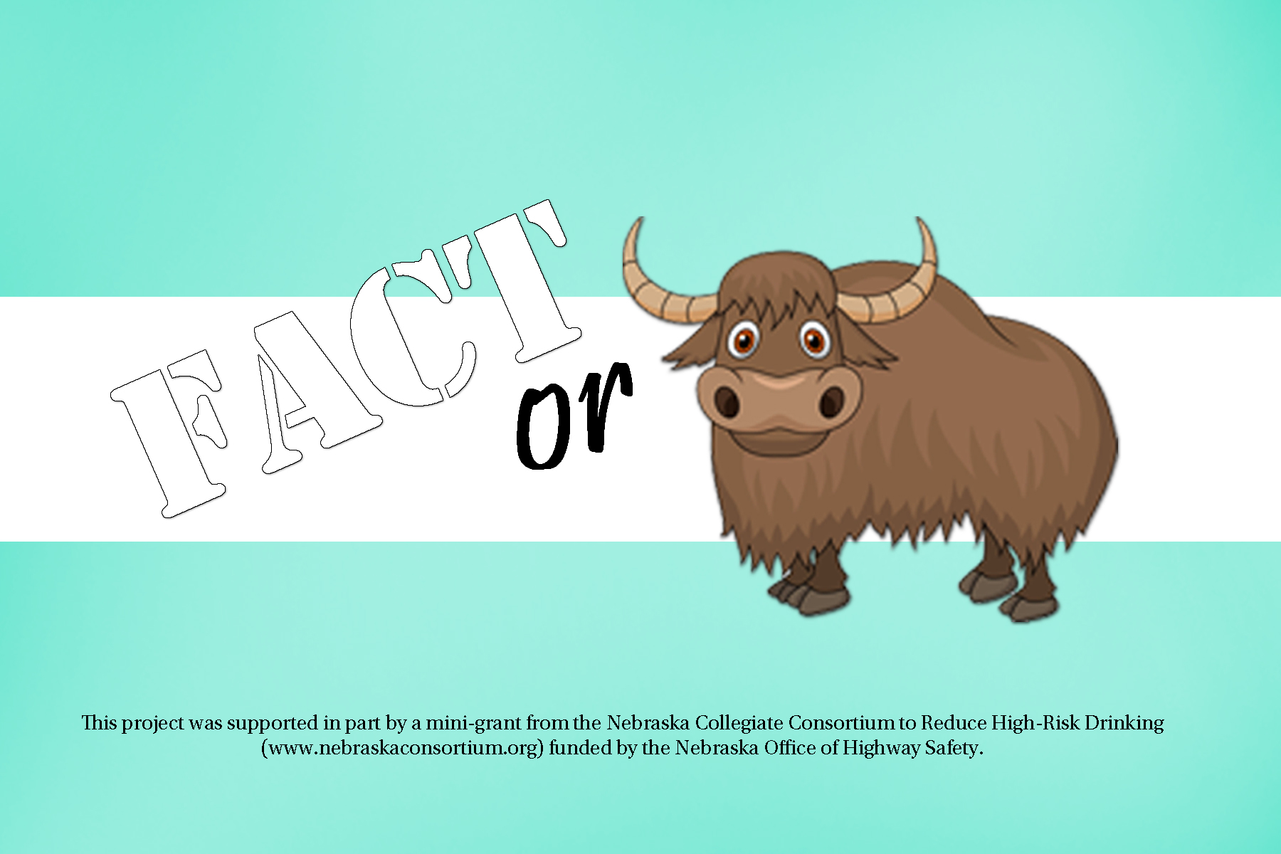
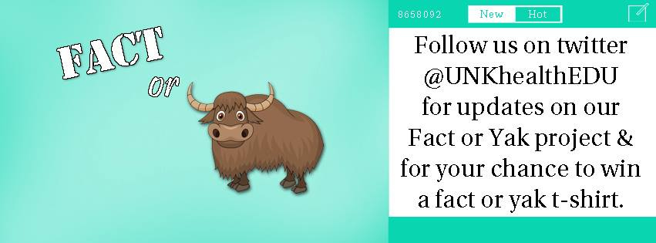

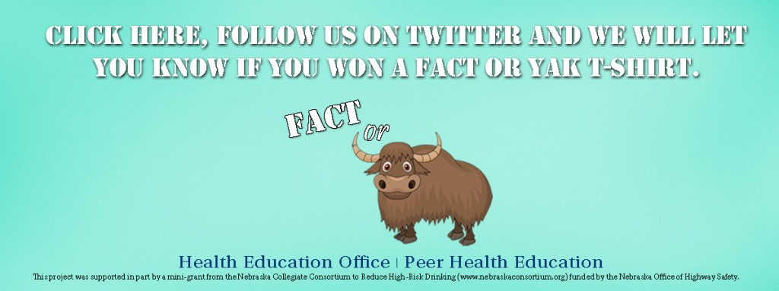

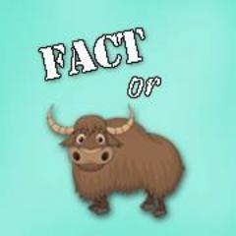

UNKhealthEDU.org web banners

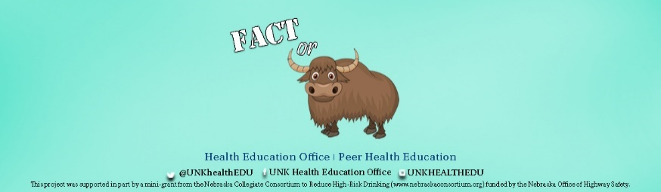

Social Media Poster embedded into posts
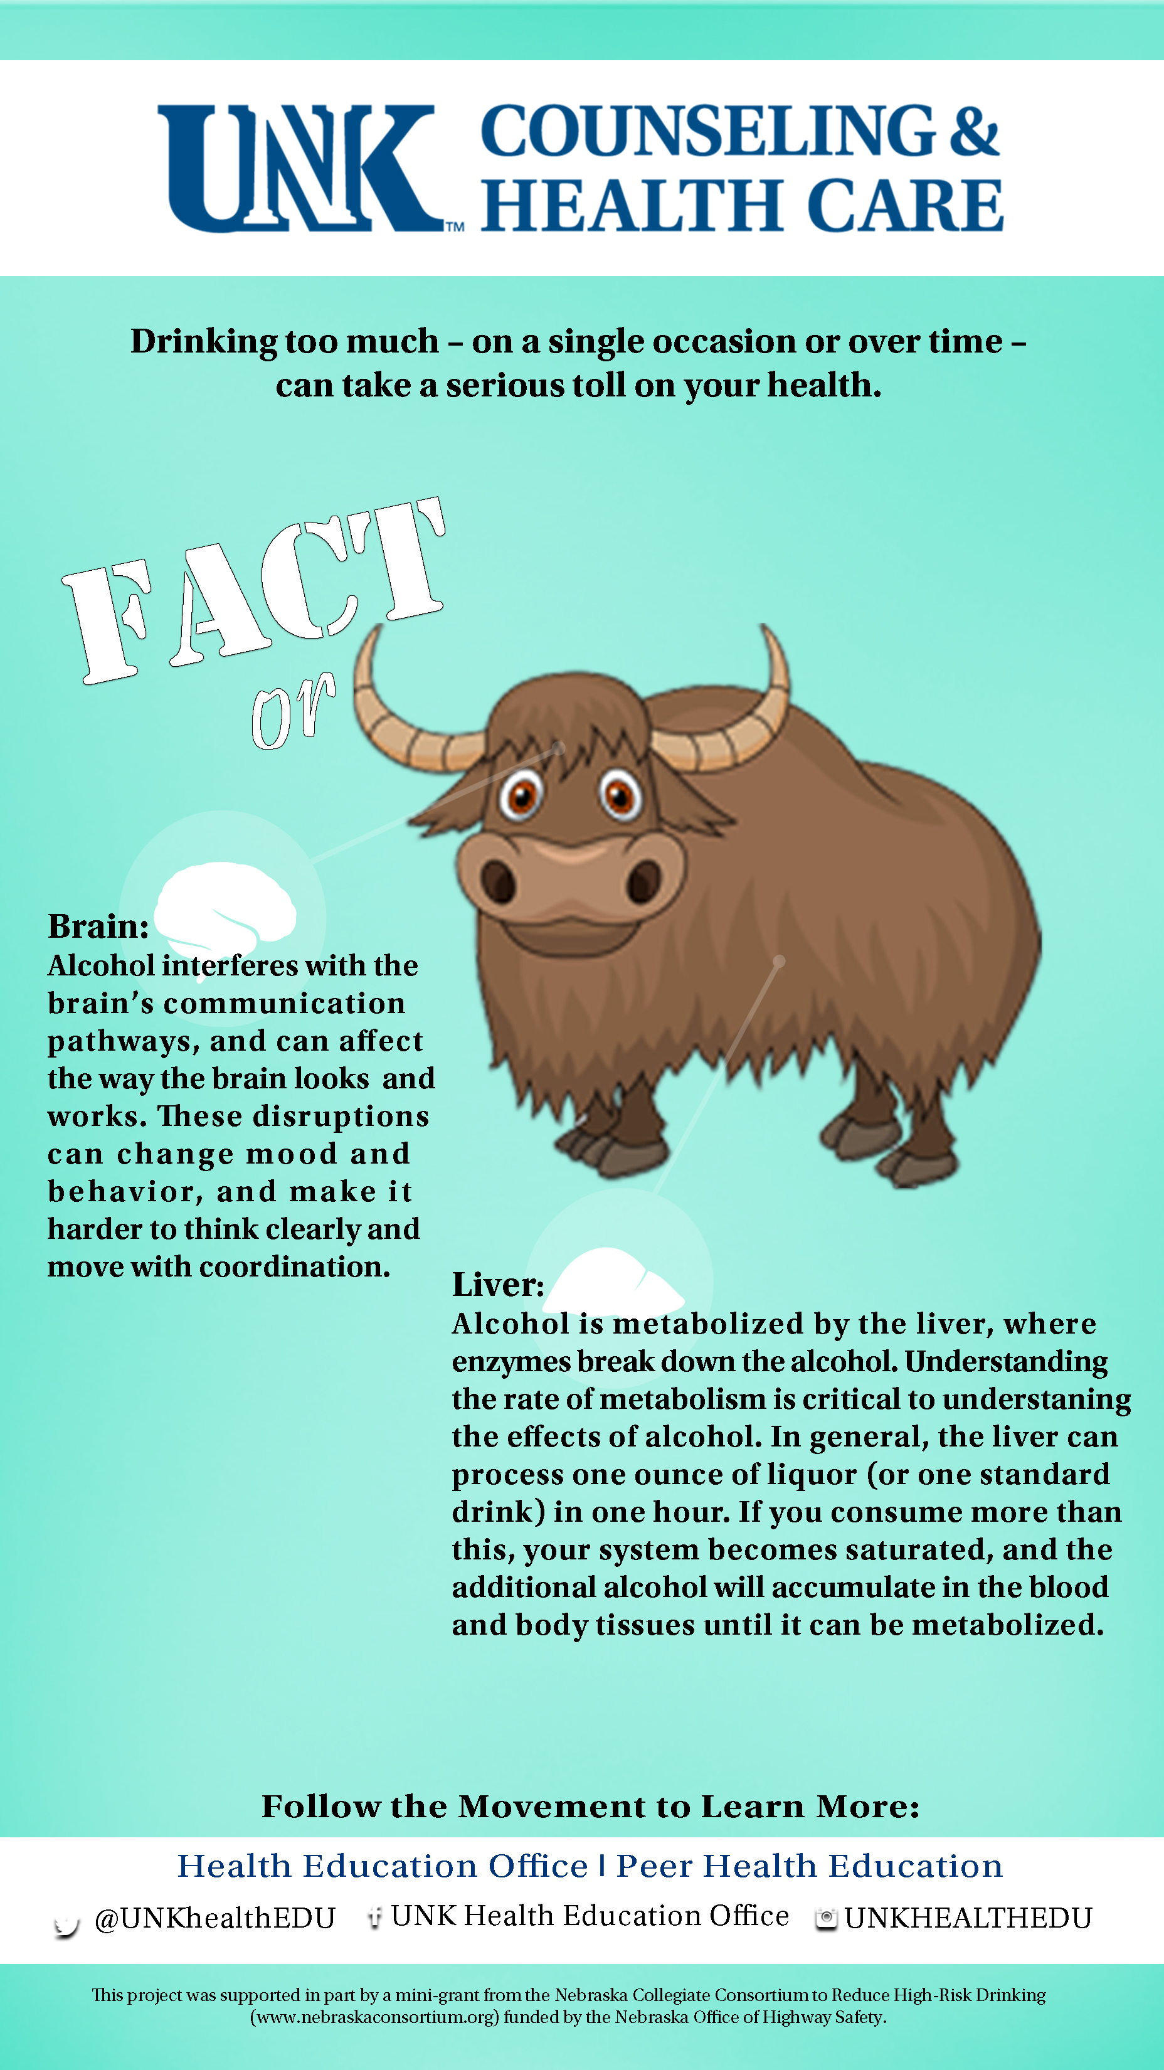

A couple of our Yaks with engagement:
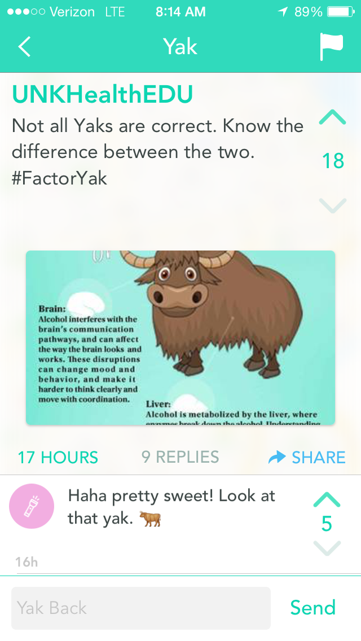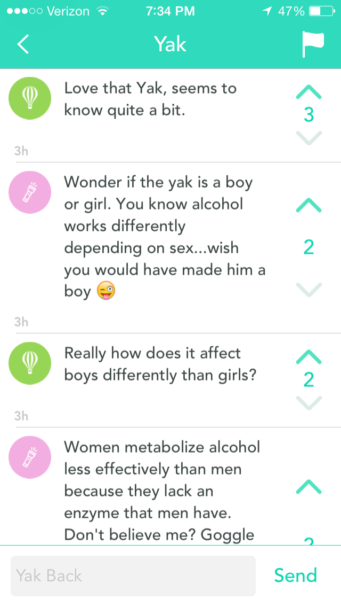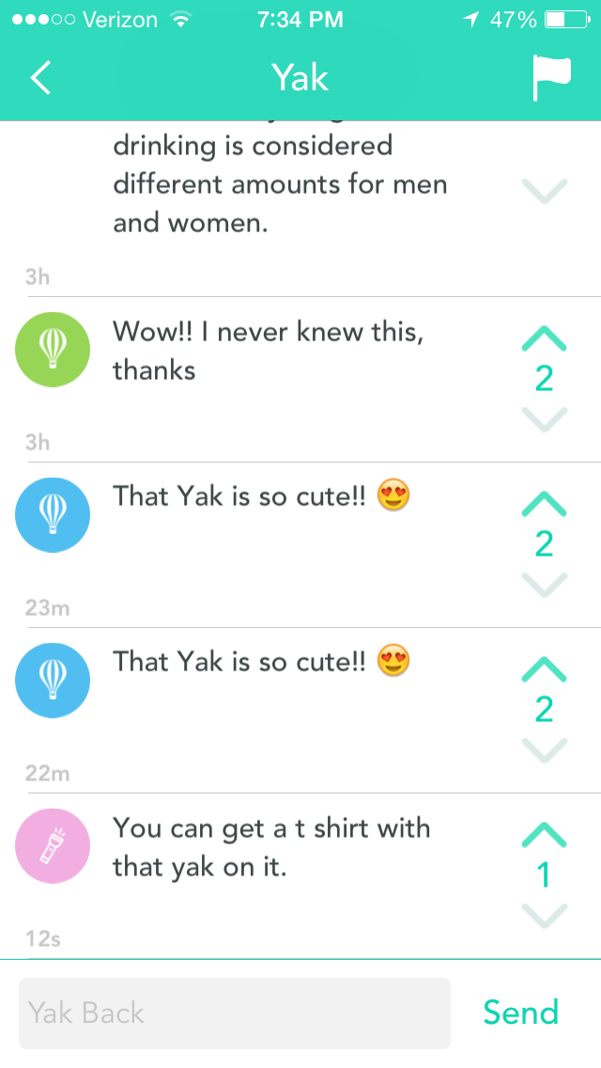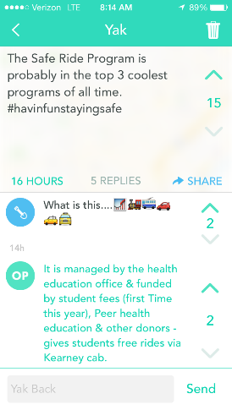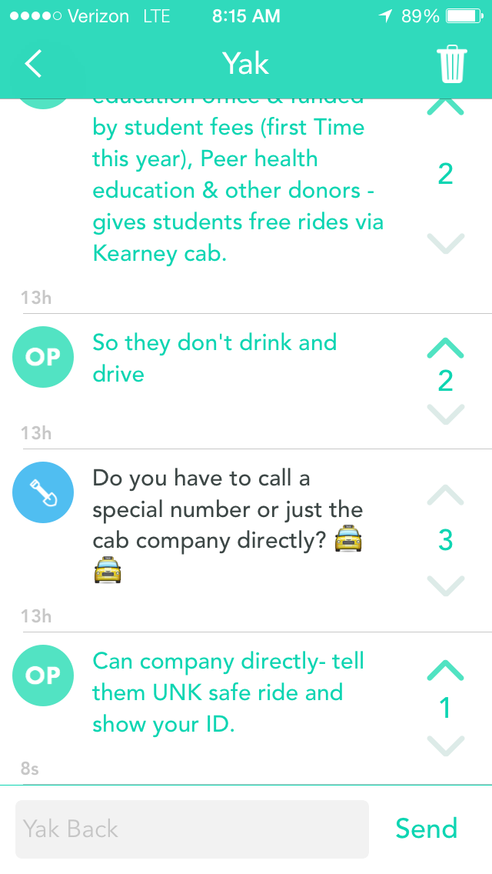

Twitter Post

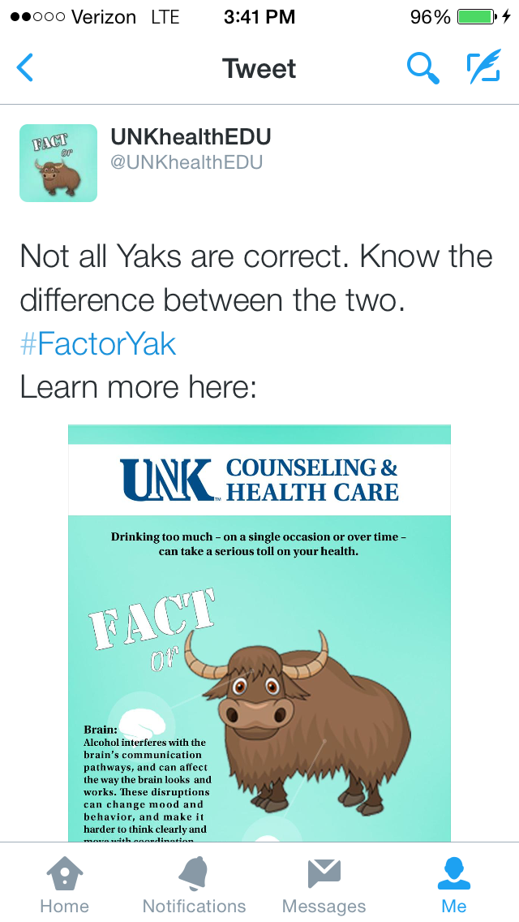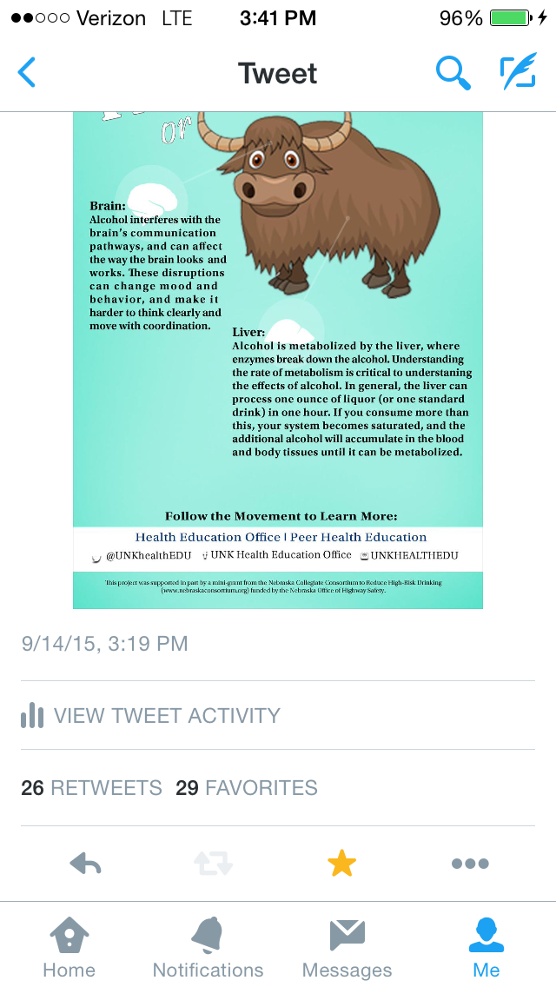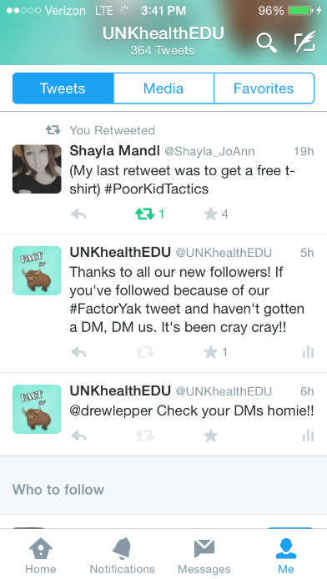

Facebook Posts and Facebook AD
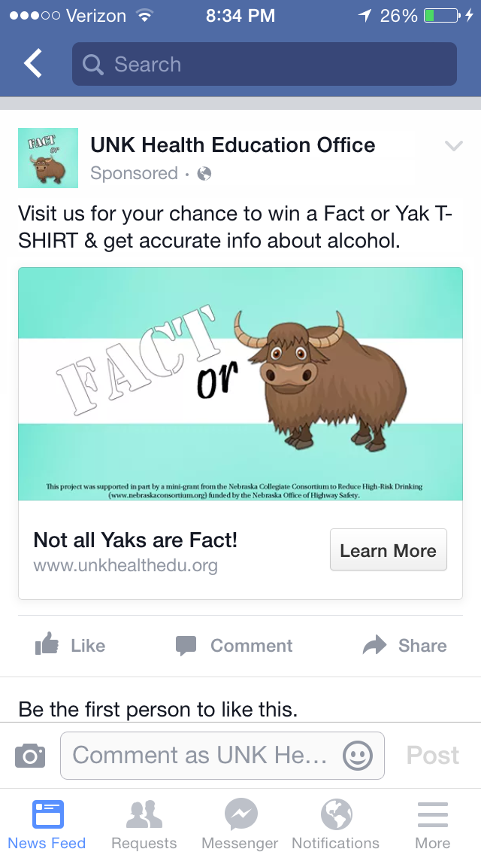

Project Evaluations
The Project was evaluated by tracking students who engaged with our social media outlets and website as well as the number of impressions we had on others’ social media walls.

New Twitter Followers:
9/14-15, 2015: 21

Twitter post
Not all Yaks are correct. Know the difference between the two. #FactorYak Learn more here: pic.twitter.com/FiWQvOlsuV

Impressions 1,820
Total engagements |  | 319
Photo or video clicks  number of clicks on photos or videos in this Tweet |  | 217
Detail expands |  | 30
Favorites |  | 29
Retweets |  | 26
Link clicks |  | 9
Profile clicks |  | 8

Facebook Posts and ADS
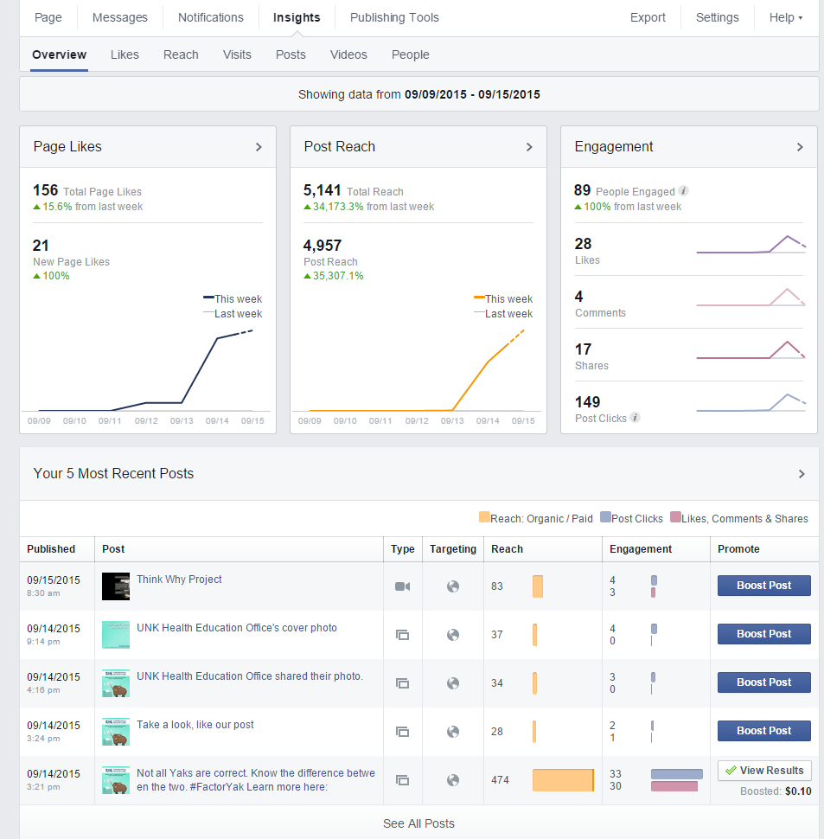

Project Budget $2,800.00
Student Worker (Helped develop the campaign): $1,804.50
Fact or Yak/SAFE RIDE T-Shirts: $750.00
Istock.com credits for Yak Vector Image and Human Body Vector Image for posters: $60.00
Social Media Advertisements: $97.97

Remaining budget: $87.53

